**Ideation Phase**

**Brainstorm & Idea Prioritization**

| Date | 16 February 2026 |
| --- | --- |
| Team ID | LTVIP2026TMIDS89357 |
| Project Name | Explore with Ai: custom itineraries for your next journey |
| Maximum Marks | 4 Marks |

**Brainstorm & Idea Prioritization Template:**

Brain storming helps us identify how Artificial Intelligence can improve travel planning. Many travelers face difficulties in planning trips that match their interests, budget, and time. Our AI-based system will solve this problem by generating personalized travel itineraries automatically.

The system will allow users to enter their preferences such as destination, budget, travel duration, and interests. Based on this input, the AI will recommend suitable places, activities, hotels, and travel schedules. It will also provide smart suggestions, optimize travel routes, and improve overall travel efficiency.

**Step-1: Team Gathering, Collaboration and Select the Problem Statement**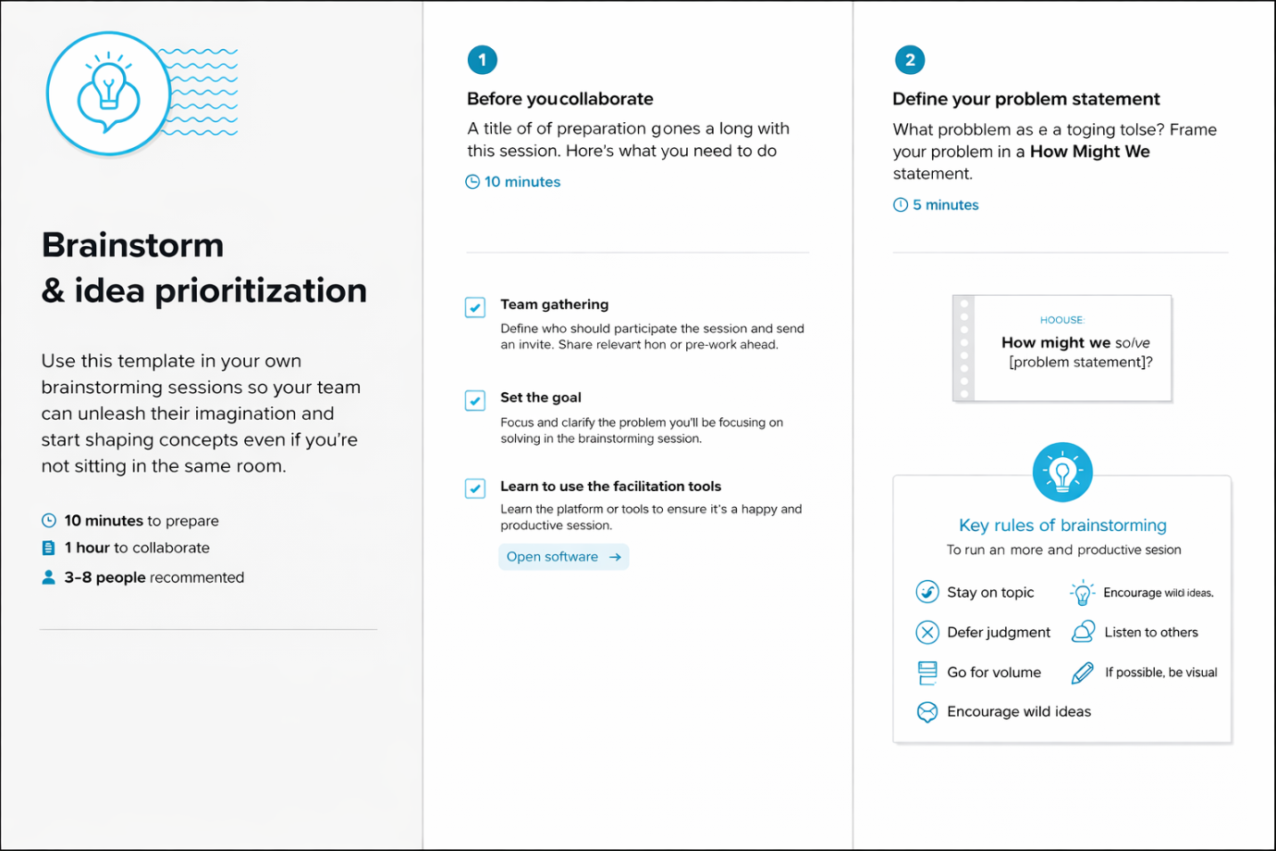

**Step-2: Brainstorm, Idea Listing and Grouping**

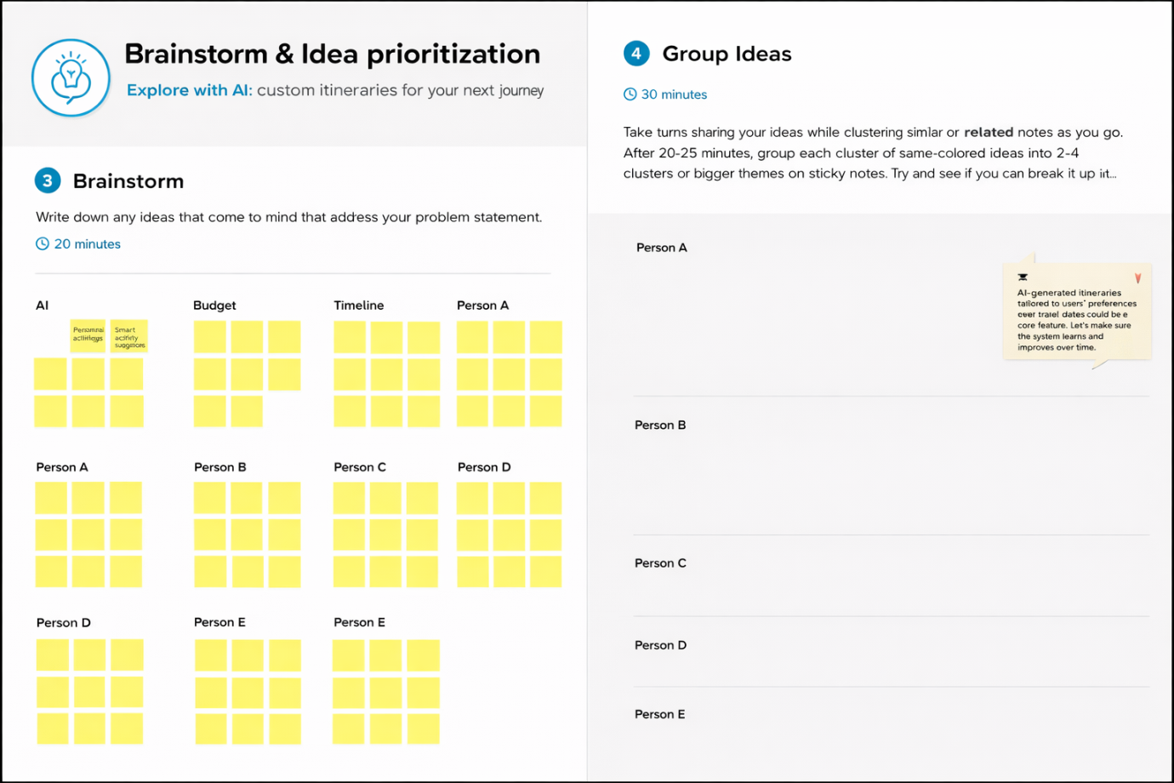

**Step-3: Idea Prioritization**

